Mr. Henry,

This week I have focused on finishing up my Unit Tests and trying to get a variety of different use cases in order to test. As I had mentioned last week, my first attempted at my online shopping cart resulted in a structure that wasn’t very easy to test and after working with a coding veteran we determined that I needed to pull my logic layer out of my code behind in order to really have good test case scenarios.

After last week, and getting my new structure in place it really made it a lot easier for me to begin setting up my unit tests.

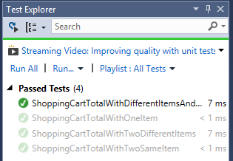

Now in my Test Explorer I have a variety of different unit tests I can run and even if I change my code I can see if different Methods are working properly.

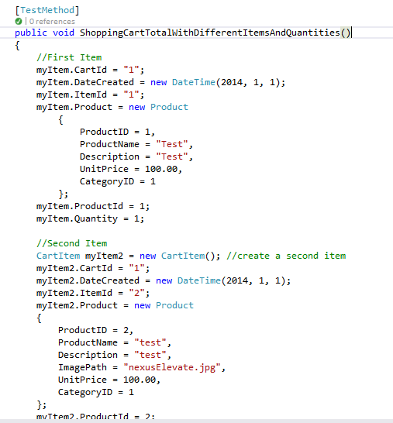

For this section of Unit Tests I have focused on making sure my shopping cart total was adding up correctly so I set up several cases where I created an instance of a CArtItem, inserted the data like I was creating one, including the price and then I used an assert statement in order to compare my manually entered value to my method to ensure the logic is working.

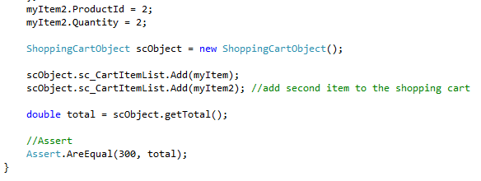

Once I have my Unit Tests completed I will move into my other types of tests.

I did find a free service to host my web site and I started reserching the Publishing Process for getting my ASP.NET application online however I’m having a redirect issue and will have to look into that further.

Hope your having a great week,

Jesse Fulcher